**Introduction 5’**

Today I’m going to present you my analysis on **lateralized vs. classic style reverse shoulder arthroplasty**. We are going to start with an Introduction to the anatomy of the shoulder joint and evolution of shoulder arthroplasty before moving on with the methods, results, and discussion.

The shoulder is among the most complex joints in the human body. Due to its’ unique anatomy with minimal bony *structures*, the shoulder joint enables us to have a huge range of motion compared to other more constrained joints, for example the hip joint. However, due to the unique properties of shoulder anatomy, the joint is very susceptible to traumatic and degenerative disorders. The combination of susceptibility to damage and a high dependency on a proper function for daily living, results in a big need for adequate treatment.

The shoulder joint consists of the two joint surfaces of the humeral head and the glenoid. As some of you may know, joint surfaces are covered with cartilage, which reduces friction between the two joint surfaces and enables a smooth movement. **GRAFIK erklären**. Scapula=shoulderblade, joint surfaces in green.

Ein Bild, das Entwurf, Axt, Werkzeug, Kunst enthält.

There are also muscles surrounding the shoulder joint, namely the Rotator Cuff and the Deltoid. The rotator cuff consists of four separate muscles and is mainly responsible for adequate centering of the humeral head in the glenoid socket, **while** **the deltoid** generates force for the movement of the arm. The deltoid lies on top of the rotator cuff and is visible quite easily.

Ein Bild, das Modeaccessoire, Sandale, Mode enthält.
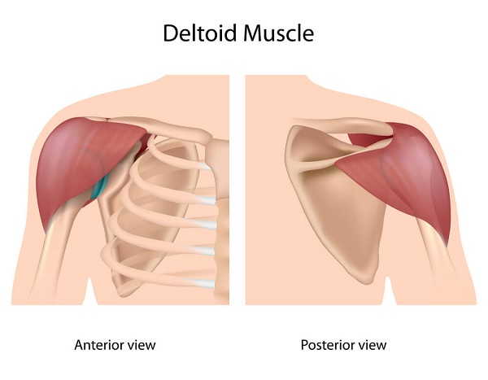

**Evolution:** In the early days of shoulder arthroplasty, most surgeons focused on so called **hemiarthroplasty**, where only the joint surface of the humeral head is replaced. Rather quickly, the treatment then evolved to **(anatomical)** **Total Shoulder Arthroplasty**, where the whole joint is replaced rather than just the humeral head. The main reason for this was to be able to address glenoid pathologies as well, which lead to improved outcomes for patients. **GRAFIK erklären.** Something to pay attention to: Center of Rotation lies in the middle of the humeral head; this will be important later.

Ein Bild, das Schuhwerk, High Heels, Sandale, Mode enthält.
Ein Bild, das Schuhwerk, High Heels, Sandale, Mode enthält.

The next step in the progression of shoulder arthroplasty was in the late 1980s, where a surgeon called Paul Grammont introduced the concept of **reverse total shoulder arthroplasty**. Due to the novel design with a large glenoid hemisphere (ball) and a small humeral cup (socket), the biomechanics of the shoulder joint change substantially. In fact, the components are inverted compared to the total shoulder arthroplasty. By doing this, the center of rotation is medialized (moved more centrally), which leads to a bigger lever arm and hence more force generation by the deltoid. Additionally, the humerus is lowered compared to the anatomical TSA, which leads to increased tension on the deltoid, which also results in a bigger force output.

However, this also leads to a phenomenon called scapular notching where the humeral component of the RSA “bangs” against the lower scapula, resulting in erosion of the bone, which can ultimately lead to loosening of the glenoid component. **GRAFIK erklären**

Nowaydays, about 70-80% of shoulder arthroplasties are reversed.

**Ein Bild, das Entwurf, Werkzeug, Design, Hebel enthält.
**

In recent years, the concept of **lateralization** has emerged. By adding small offset of a few milimeters to the glenosphere the rate of notching should be reduced, because of the increased distance of the humeral component to the lower scapula.

Furthermore, deltoid tension should be even more increased and in turn should result in a larger deltoid force generation. **GRAFIK erklären.**

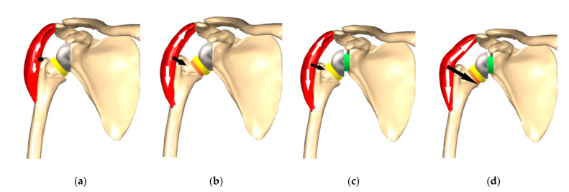

By the way, this is what a reverse shoulder arthroplasty looks like before and after on an X-Ray. Pay attention to the Center of Rotation again! **XRAY.**

In this analysis, the goal is to explore relationships between lateralized and regular RSA in selected subjective and objective outcome measures two years after implantation.

**Methods 2’**

Patients from the local Shoulder Arthroplasty Registry at Schulthess Clinic treated with reverse shoulder arthroplasty, model Aequalis, (because the notching data is available)

Excluded all revision operations, keep only primary implantations.

Groups: Classic configuration without Lateralization

Lateralized glenoid

The outcome measures I used were the constant Score, which is a composite score of several objective parameters, such as abduction strength and Range of motion. It ranges from 0 to 100 with 100 being the highest possible score.

Then I also looked at a patient reported outcome measure, the subjective shoulder value. It reflects the subject percentage, that the patients’ shoulder has in comparison to a healthy shoulder. The range is also from 0 to 100, with 100 being the highest attainable score. A score 100 essentially means that the shoulder feels completely healthy to the patient.

I also included a radiological parameter, the grade of notching. It’s a categorical variable and ranges from 0 to 4. Zero meaning no sign of notching with increasing severity from 1 to 4. You can see the different grades of notching in the picture on the right.

**My hypothesis is that reverse shoulder arthroplasties with a lateralized glenoid do better in Constant Score and SSV and have a reduced rate of scapular notching than reverse shoulder arthroplasties with a classic glenoid configuration.**

I used the D’agostino pearson test for normality, the Unpaired t-test for normally distributed outcome variables with Welsch’s correction if needed and the mann whitney u test for non-normally distributed outcome variables. for categorical data (notching grade) I used Chi2 test. The level of confidence was set at 95%, which means the level of alpha was 0.05. Libraries used were pandas, numpy, matplotlib and scipy.

**Results 5’**

Let’s talk about the results. On this slide you can see the demographics for the two groups. I selected Gender, Age, BMI, ASA Classification and Diagnosis as the main demographic variables. As you can see, the two groups are very similar in all the selected parameters.

Now, first I want to talk about the subjective shoulder value. In the **left** plot you can see the pre and post-surgery boxplots of the SSV, split by groups. Obviously, both groups improved tremendously with shoulder arthroplasty. However, when looking at the change of SSV, it seems that there is no difference between the groups. Statistically (*mann-whitney u test*) this results in a **p-value of 0.93**. This means it is likely our samples have been drawn from the same population.

Then when looking at the Constant Score, a very similar trend can be seen. Again, a big improvement after implantation, but then again, no difference between the groups. The **p-Value is at 0.88** (*mann-whitney u test*).The numbers indicate that there is a high probability the samples have been drawn from the same population as well.

When it comes to the grade of notching, visually, it seems beneficial to lateralize the glenoid. In the left barplot you can see all the values for notching grades. Using the chi squared test, a p value of 0.25 results. Once again, it seems the groups are not different from each other.

The right barplot I added just to better visualize the different grades of notching. As a grade of zero stands for no notching, I removed these values. So, the right plot only shows notching from grade 1 to 4.

I also compared a lot of subgroups with each other but haven’t been able to find any statistically significant differences at all. For example, only looking at men or women, looking at high BMI or regular BMI, looking at high or low ASA patients, looking at specific diagnoses only etc.

**Discussion 3’**

In conclusion, no statistically significant difference was found for either of the groups. Neither for the change of SSV, nor for the change of constant Score, nor in the grade of notching at 2 years post surgery. There might be a slight trend towards lower rates of notching in the lateralized group, however not statistically significant.

**After analyzing this data, my conclusion would be that currently there is no advantage of incorporating lateralization in reverse shoulder arthroplasty.**

Thankyou for listening and I’m happy to answer your questions.

Quellen:

1. [Grammont reverse prosthesis: design, rationale, and biomechanics - PubMed (nih.gov)](https://pubmed.ncbi.nlm.nih.gov/15726075/)
2. [Etude et réalisation d'une nouvelle prothèse d'épaule | Semantic Scholar](https://www.semanticscholar.org/paper/Etude-et-r%C3%A9alisation-d%27une-nouvelle-proth%C3%A8se-Grammont-Trouilloud/ce86490e649299d28303798d257d14c9b2642fbe)
3. [Lateralization in Reverse Shoulder Arthroplasty - PMC (nih.gov)](https://www.ncbi.nlm.nih.gov/pmc/articles/PMC8623532/)

Grafiken: [Glenohumeral (Shoulder) joint: Bones, movements, muscles | Kenhub](https://www.kenhub.com/en/library/anatomy/the-shoulder-joint)

[Rotator Cuff Tears Anatomy | Town Center Orthopaedics](https://www.towncenterortho.com/blog/rotator-cuff-tears-anatomy-and-causes-video/)

[Total Shoulder Arthroplasty vs Hemiarthroplasty for Rheumatoid Arthritis of the Shoulder | Doctor Shoulder](https://doctorshoulder.co.za/total-shoulder-arthroplasty-vs-hemiarthroplasty-for-rheumatoid-arthritis-of-the-shoulder/)

[Scapular notching and osteophyte formation after reverse shoulder replacement | Bone & Joint (boneandjoint.org.uk)](https://boneandjoint.org.uk/Article/10.1302/0301-620X.95B4.30442)